The English Plan
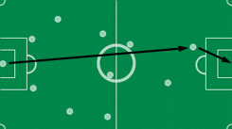
Depending on the wind, the striker’s position may vary…

The German Plan
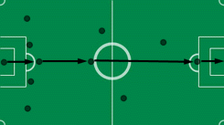
Radical, efficient, unstoppable… (ball’s speed may reach 297 km/h)

The Italian Plan
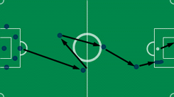
Iron defense, small presence in midfield, passes to striker.. and…Penalty

The Brazilian Plan
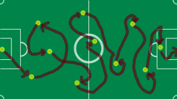
No comments...

The Belgian Plan
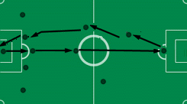
They manage to lose the game by themselves, no help needed.

The Spanish Plan

Where’s the Spanish plan… ?

The French Plan
In a plan designed by Roger Lemerre, they try all possible hypotesis. Note the player in the midfield trying to play by himself…

The Portuguese Plan
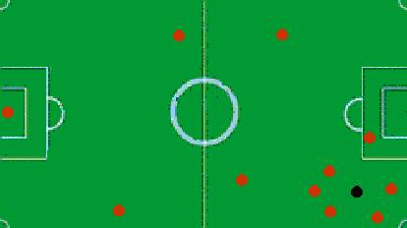
The black dot is not the ball, it’s the referee.

The Irish Plan.

Left on a flight last week.

